**Quick Start Users guide**

1. Navigation bar like below is provided on the left side of the page to perform the actions

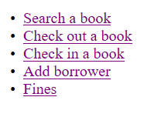

1. Searching a book is enabled on providing any of the keywords in the search bar of the mail page (Search a book Page)

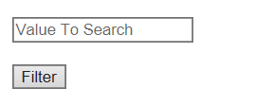

1. Checking out/In a book is done on filling the below fields and clicking submit in the Checking Out/ In a book pages

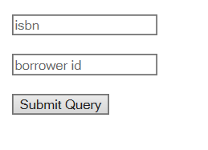

1. Following fields need to be filled in the add borrowers page to add a new borrower to the data base

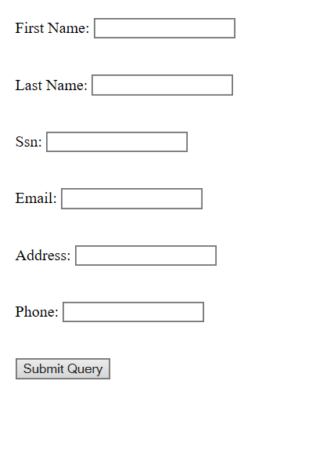

1. Fines are calculated on clicking the below button of fines page

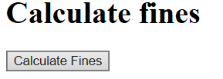

Enter loan id and click on update fines to update a fine record with provided loan id to paid

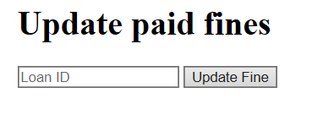

Click on the below button to show paid fines

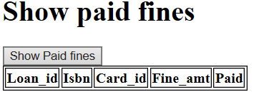

Click on below button of the fines page to show total fines paid

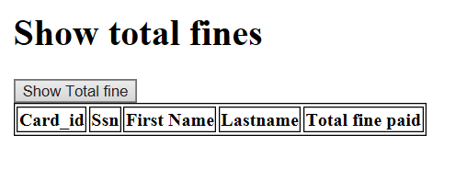

1. Error messages for different scenarios are displayed whenever validation fails. For example, below message is displayed when ssn provided while creating a new borrower’s record already exists in the data base.

